- IDENTIFICATION OF MAIN COMPONENTS FOUND INSIDE A DESKTOP PC CABINET

- INTRODUCTION:

A desktop computer consists of several internal hardware components that work together to perform different tasks. Each component has a specific function, such as processing data, storing information, supplying power, or displaying graphics. Identifying these components helps in understanding the basic structure and operation of a desktop PC.

- MAIN COMPONENTS

- Motherboard
- The motherboard is the main circuit board of the computer.
- It connects and allows communication between all hardware components.

- CPU (Central Processing Unit)
- The CPU is the brain of the computer.
- It processes instructions and performs all calculations.

- CPU Cooler
- The CPU cooler prevents the processor from overheating.
- It usually consists of a heatsink and a cooling fan.

- RAM (Random Access Memory)
- RAM stores temporary data required by running programs.
- More RAM helps the computer perform multiple tasks smoothly.

- Storage Drive (SSD/HDD)
- SSD or HDD stores the operating system, software, and user files.
- SSD is faster than HDD and provides quicker boot and loading times.

- Graphics Card (GPU)
- The GPU processes graphics, videos, and 3D applications.
- It improves gaming, video editing, and graphic performance.

- Power Supply Unit (PSU)
- The PSU converts AC power into DC power.
- It supplies electricity to all internal computer components.

- Cabinet Fans
- Cabinet fans improve airflow inside the cabinet.
- They help keep the internal components cool.

- SATA Data Cable
- It connects the storage drive to the motherboard.
- It transfers data between the storage device and the system.

10. Power Cables
- Power cables deliver electricity from the PSU.
- They power the motherboard, storage drives, GPU, and other components.

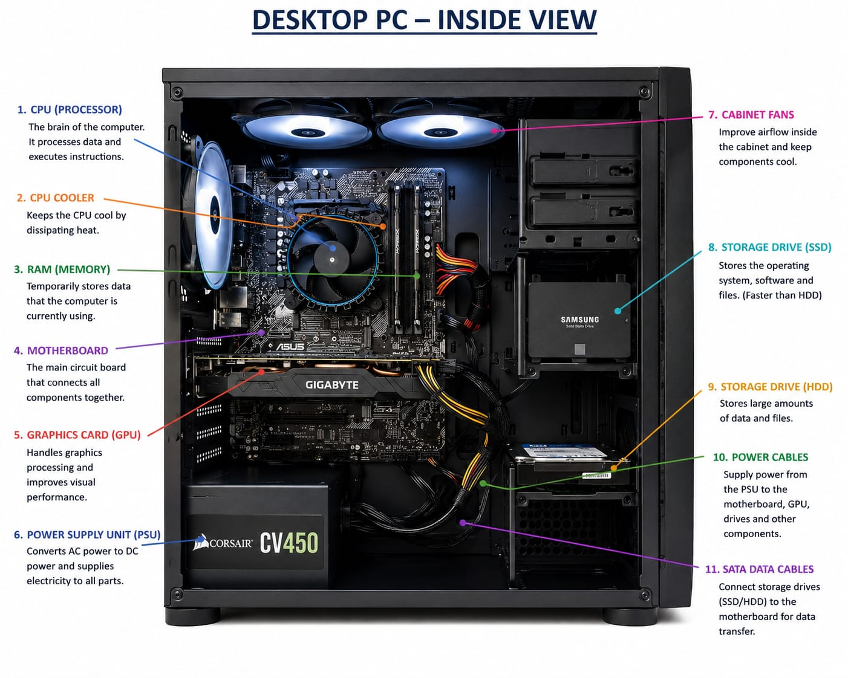

- CONCLUSION:

The pc assembly and disassembly process should always be performed carefully using the correct tools and safety precautions. Following proper steps helps protect hardware components from damage, make troubleshooting easier, and ensures the computers work correctly after reassembly. Proper documentation of each step also improves understanding and maintenance skills.
- DESKTOP PC DISASSEMBLY PROCESS

- INTRODUCTION:

Desktop PC disassembly is the process of safely opening the computer cabinet and removing internal hardware components. Each step must be performed carefully to avoid damaging the components and to ensure proper reassembly.

- STEP-1: Shut down and Unplug the Computer
- Turn off the computer completely.
- Disconnect the power cable and all external devices.

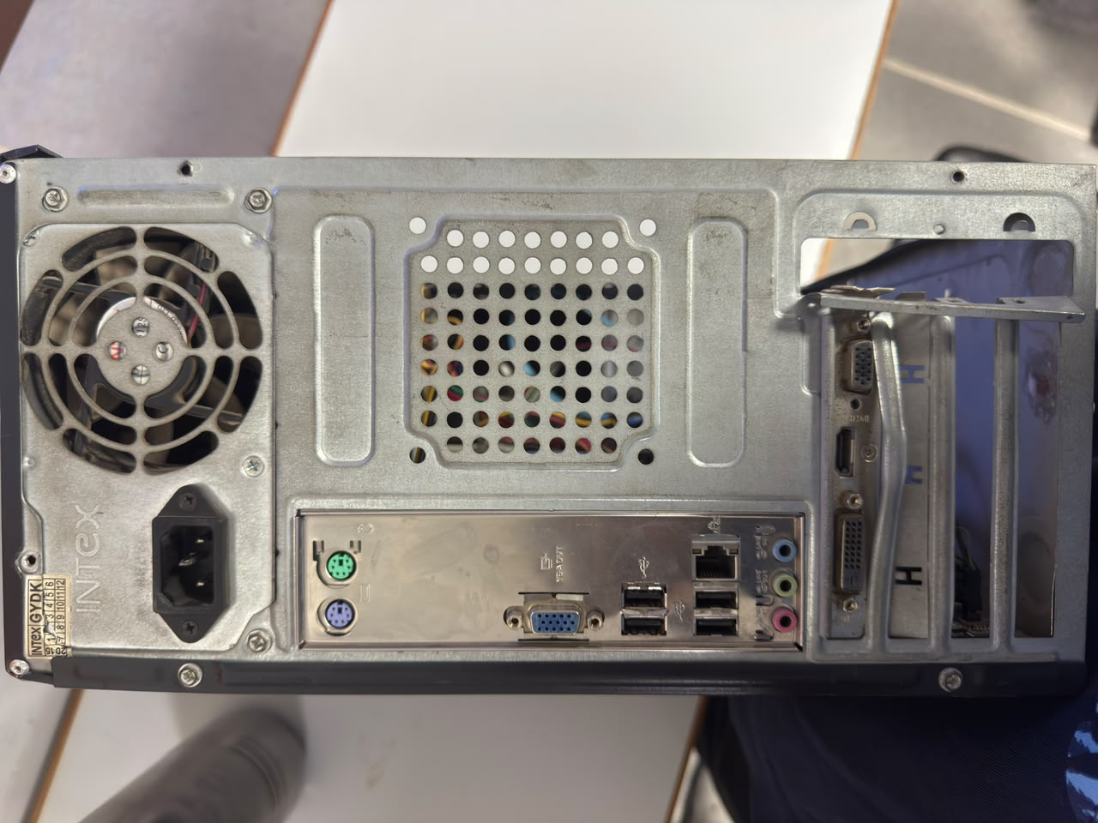

- STEP-2: Open the Desktop Cabinet

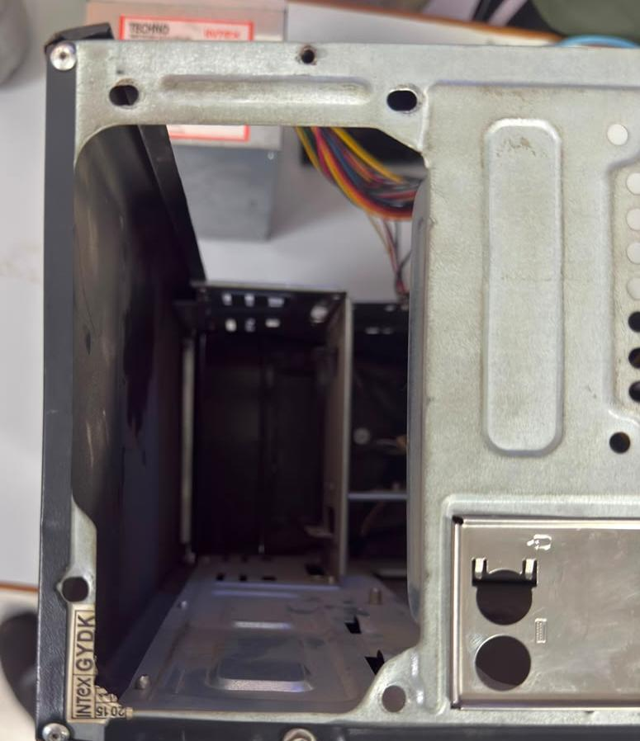

- STEP-3: Empty Cabinet

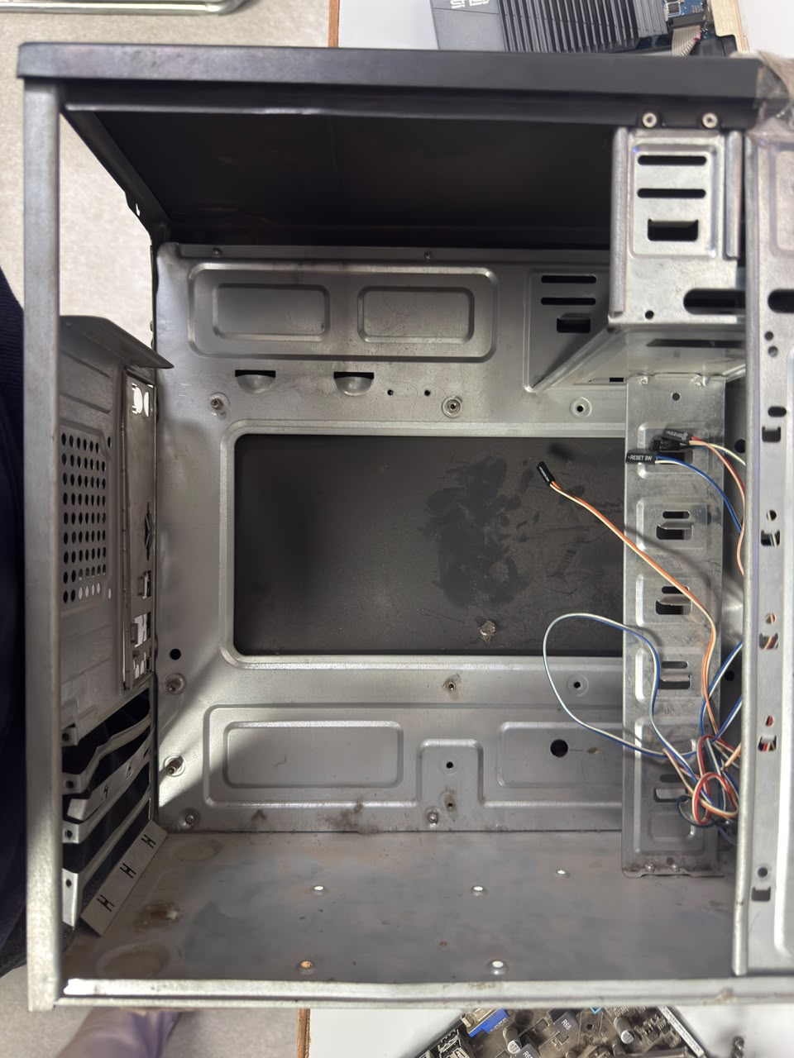

- STEP-4: Motherboard Removed
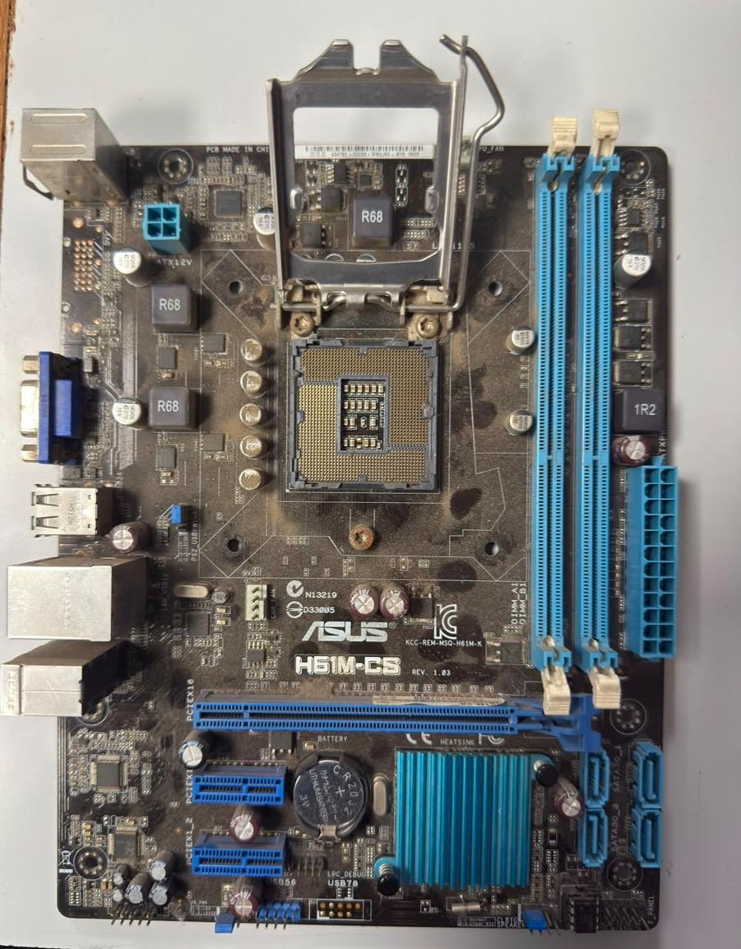

- STEP-5: Install Motherboard

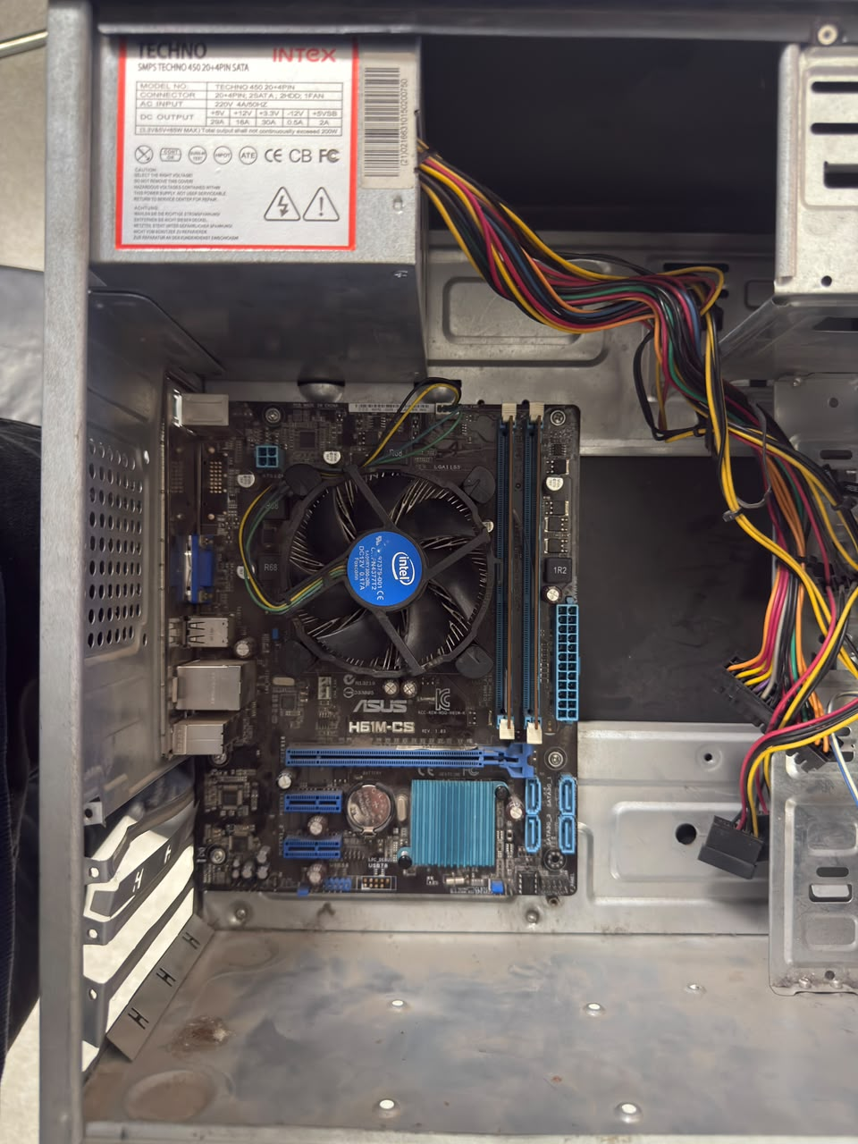

- STEP-6: Connect Power Supply (SMPS)
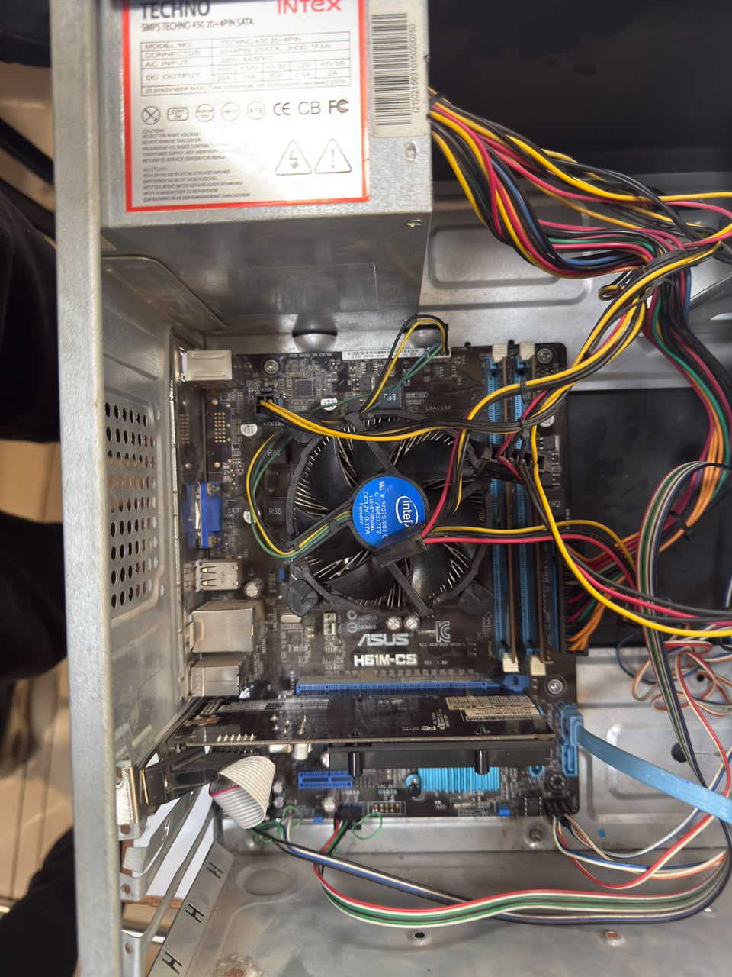

- STEP-7: Install SSD
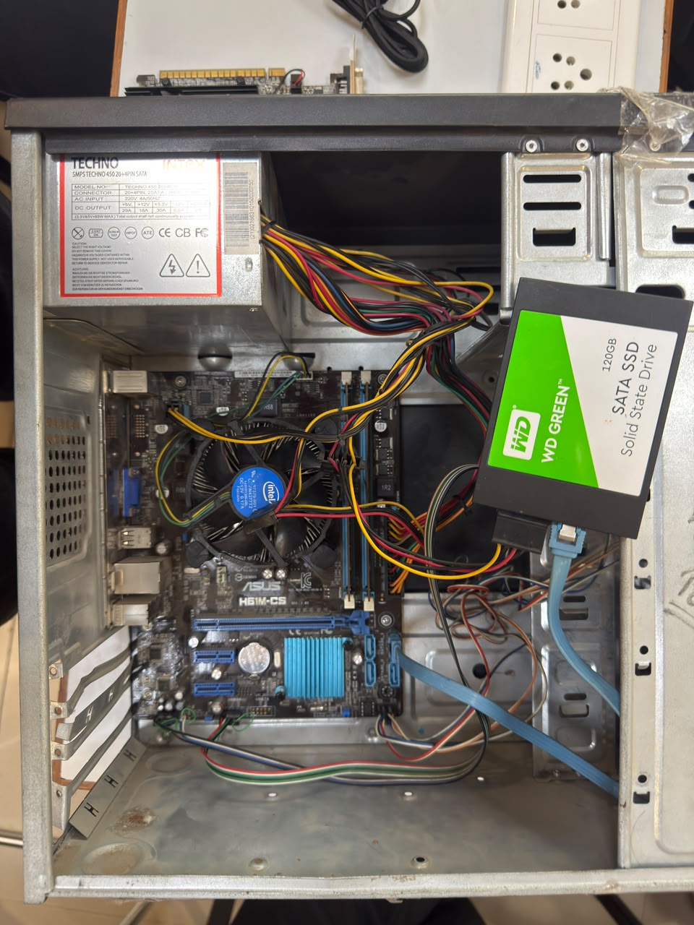

- STEP-8: Install Expansion card/GPU


The arrow was there in the image and the graphics card was inserted into the PCle x16 slot and secure with a screw.
- STEP-9: Rear Panel Check

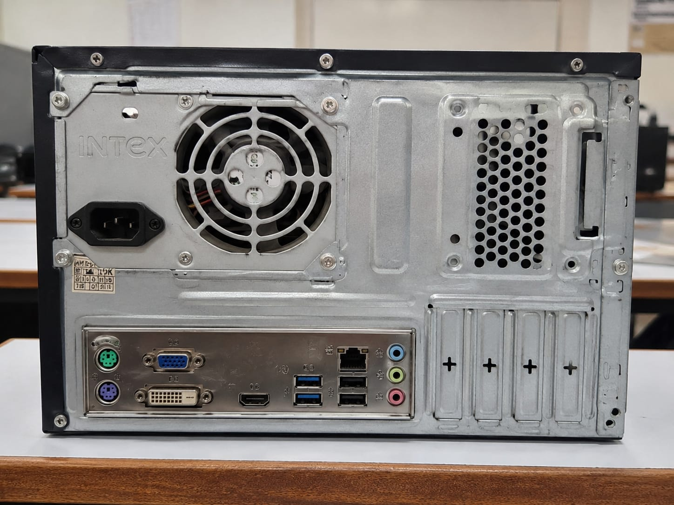

- CONCLUSION:

The desktop PC was successfully disassembled and reassembled by following the correct safety procedures and sequence. During this practical, I learned how to identify computer components, remove and reinstall them properly, connect cables correctly, and verify the system after assembly. This activity improved my understanding of desktop hardware, troubleshooting, and safe PC maintenance.

- REASSEMBLE THE DESKTOP PC

- INTRODUCTION:
Desktop PC reassembly is the process of installing all computer components back into the cabinet in the correct order after disassembly. Proper reassembly ensures that every component is securely connected and the computer operates safely and efficiently.

- STEP-1: Install the Power Supply Unit (SMPS)

- The SMPS was placed inside the cabinet and secured with screws.
- It provides electrical power to all computer components.

- 
- STEP-2: Install the Motherboard

- The motherboard was aligned with the cabinet standoffs and fixed using screws.
- All components are connected through the motherboard.

- STEP-3: Install the RAM Module

- The RAM module was inserted into the correct DIMM slot until the locking clips clicked into place.
- RAM allows the computer to store temporary data while programs are running.
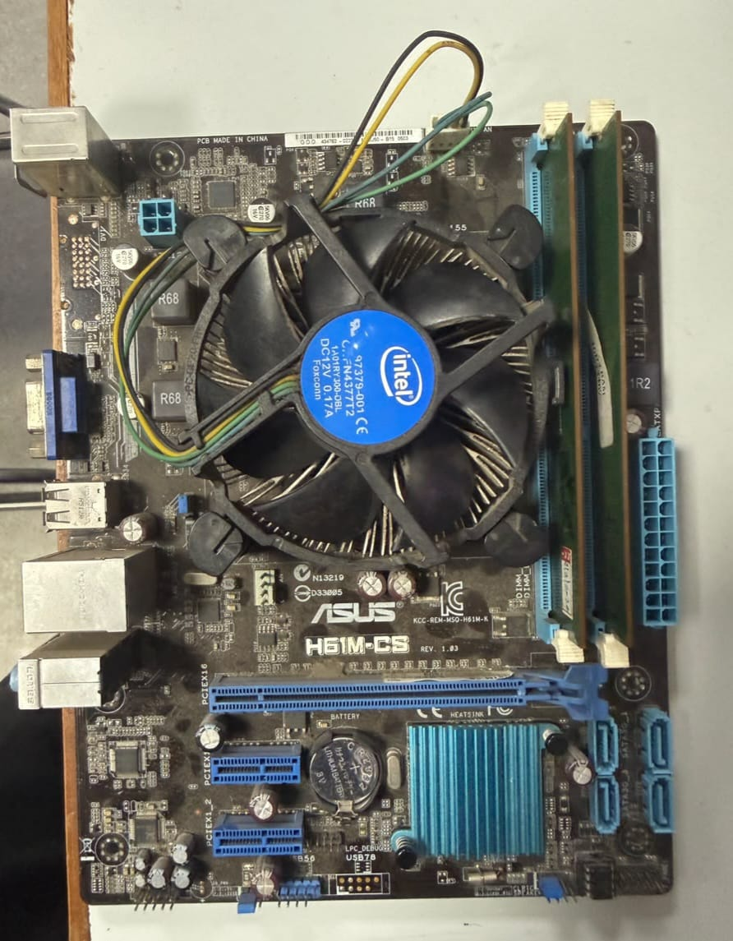

- STEP-4: Install the storage drive (SSD/HDD)
- The SSD/HDD was mounted in the drive bay.
- SATA data and power cables were connected properly.

- STEP-5: Install the Graphics Card

- The Graphics card was inserted into the PCle slot and secured with a screw.
- Any required PCle power cable was connected.

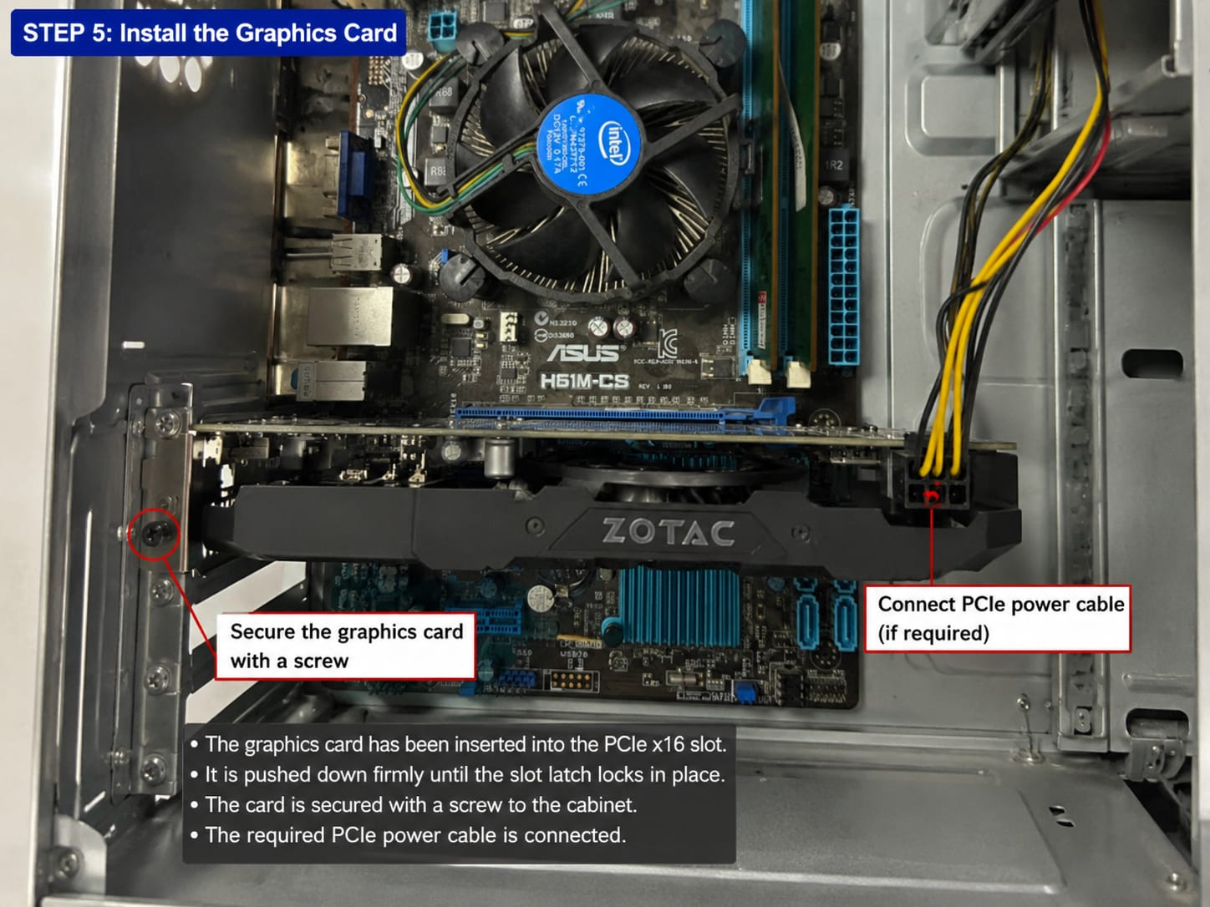

- STEP-6: Connect All Internal Cables

- The 24-pin motherboard power cable, CPU power cable, SATA cables, front panel connectors, USB, and audio cables were connected.
- Cable connections were checked to ensure they were secure.

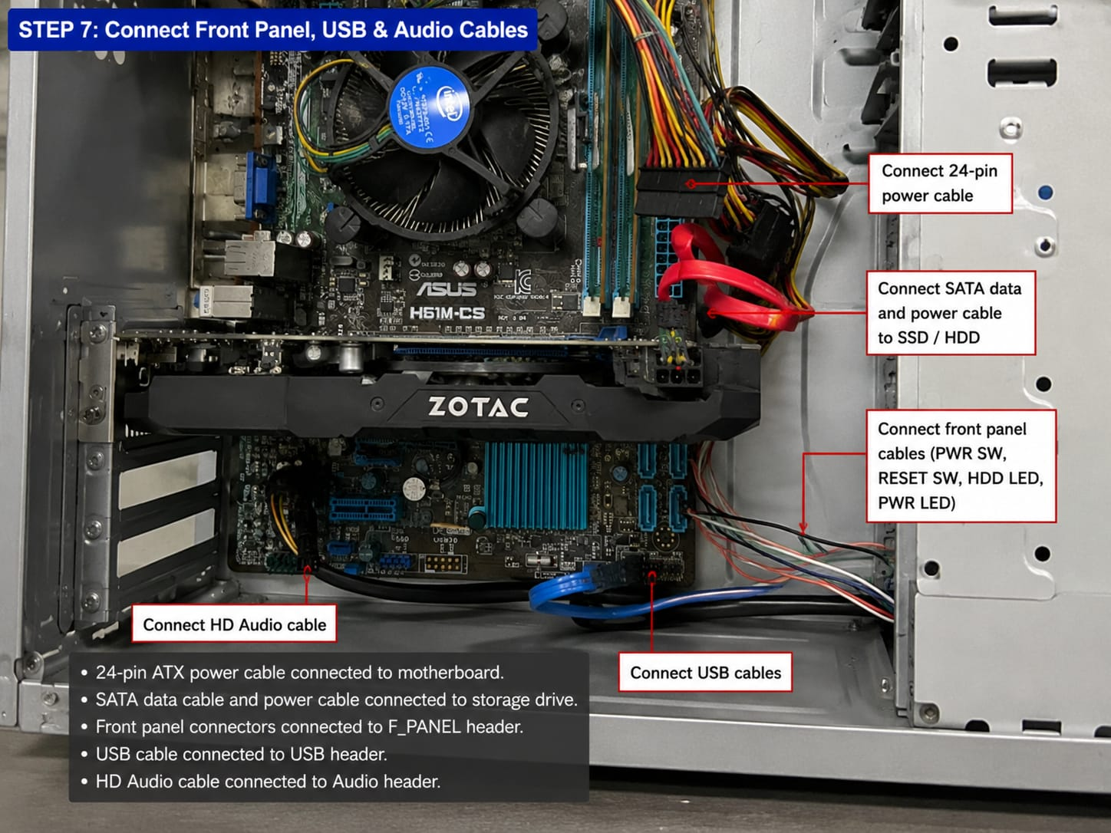

- STEP-7: Close the Cabinet
- The side panel was reattached and tightened with screws.
- The cabinet was inspected before powering on the computer.

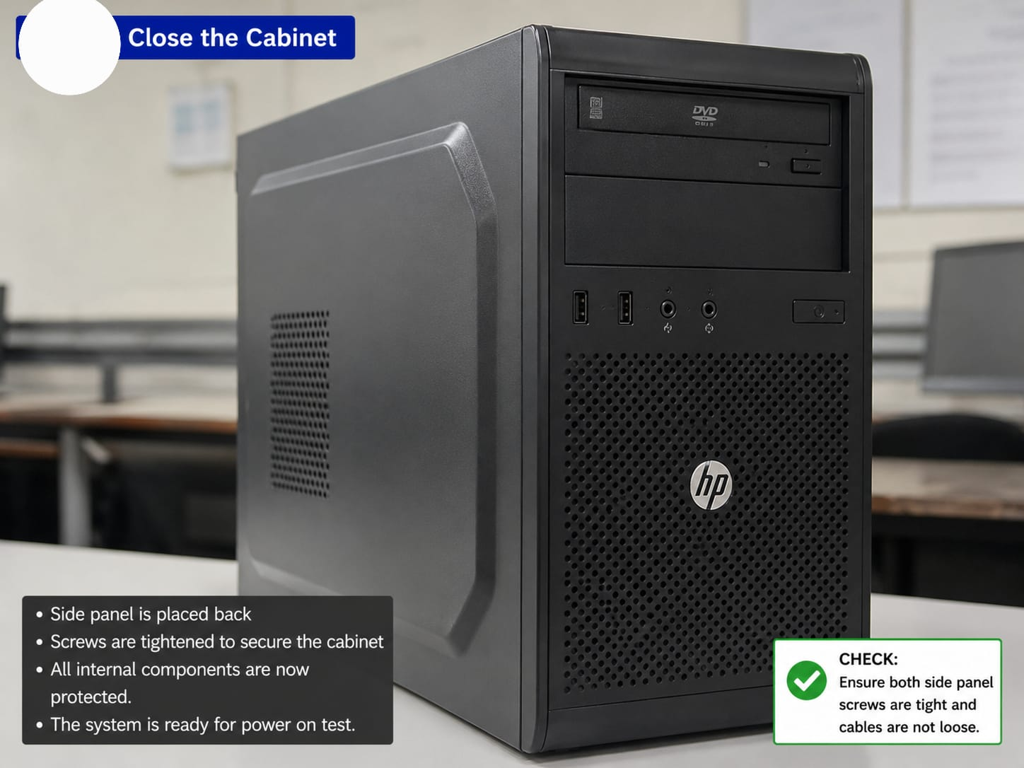

- STEP-8: Power On and Verify

- The computer was switched on.
- The system booted successfully, confirming that all components had been reassembly correctly.
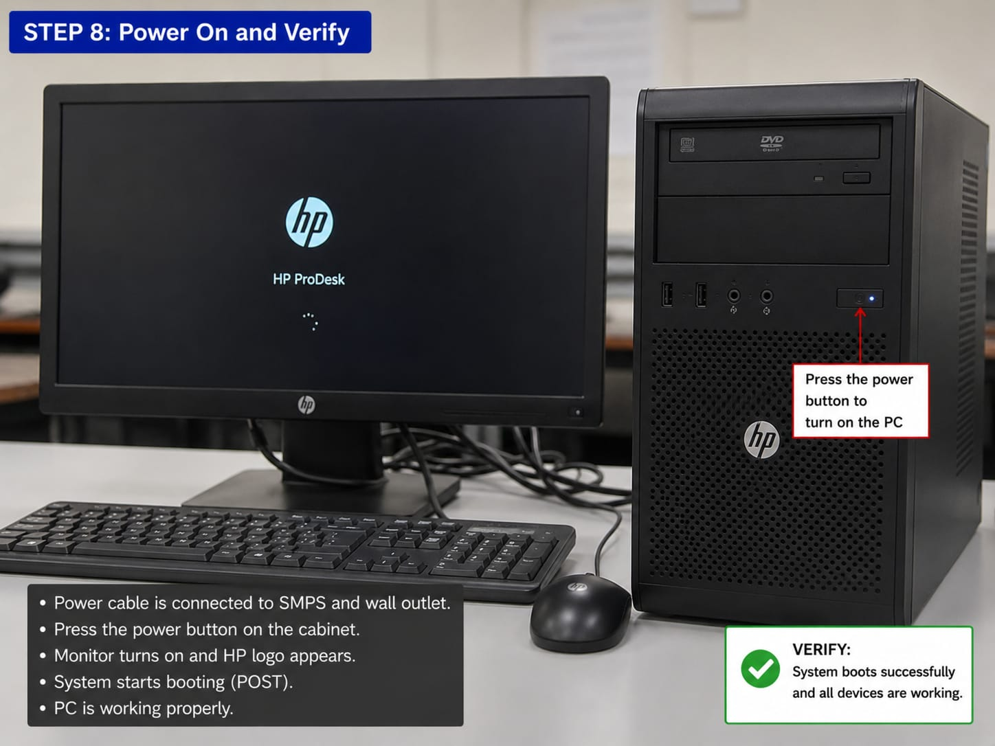

- CONCLUSION:

The desktop PC was successfully reassembled by following the correct installation sequence. All components were installed securely, cables were connected properly, and the system booted successfully. This practical activity improved my understanding of desktop hardware installation, cable management, and safe computer maintenance.
- SAFELY PRECAUTIONS AND TOOLS REQUIRED BEFORE PC ASSEMBLY/DISASSEMBLY

- INTRODUCTION:

Before starting the assembly or disassembly of a desktop computer, it is essential to prepare the required tools and follow all safety precautions. Computer components such as the motherboard, processor, RAM, storage devices, and power supply are sensitive to dust, static electricity, and physical damage. Using proper tools and following correct safety practices helps protect the hardware, prevents accidents, and ensures the work is completed safely and efficiently.

- TOOLS REQUIRED

- Phillips Screwdriver
Used to remove and tighten screws while opening the cabinet, mounting the motherboard, installing storage devices, power supply, and expansion cards.
- Flat Head Screwdriver
Useful for opening certain cabinet clips and removing components that require a flat screwdriver.
- Anti-Static Wrist Strap
Protects sensitive electronic components from Electrostatic Discharge (ESD) by grounding the user while handling internal hardware.
- Soft Cleaning Brush
Used to remove accumulated dust from the motherboard, cooling fan, power supply, RAM slots, and cabinet without damaging components.
- Microfiber Cloth
Helps clean the cabinet and components safely without leaving scratches or lint.
- Thermal Paste
Applied between the CPU and heatsink whenever the processor cooler is removed to ensure efficient heat transfer.
- Cable Ties (Zip Ties)
Used to organize cables inside the cabinet, improving airflow and making future maintenance easier.
- Small Container or Magnetic Tray
Keeps screws and small accessories safely stored to prevent them from being misplaced during disassembly.
- Flashlight (Optional)
Provides better visibility inside the cabinet while connecting cables or identifying motherboard headers.

- Safety Precautions

- Shut Down the Computer Properly
Always shut down the operating system completely before opening the computer cabinet.
- Disconnect the Power Supply
Remove the power cable from the SMPS and disconnect all external devices such as the keyboard, mouse, monitor, speakers, LAN cable, and USB devices.
- Discharge Residual Electricity
After unplugging the system, press and hold the power button for 5–10 seconds to release any remaining electrical charge.
- Wear an Anti-Static Wrist Strap
This prevents electrostatic discharge that can permanently damage sensitive electronic components.
- Handle Components Carefully
Always hold the motherboard, RAM, graphics card, and processor by their edges. Never touch the gold contacts or integrated circuits.
- Work on a Clean and Dry Surface
Place all components on a flat, clean, and non-conductive surface to avoid scratches, dust, or electrical damage.
- Keep Liquids Away
Water or any liquid should never be kept near the computer while assembling or disassembling.
- Do Not Force Components
If a component does not fit easily, check its orientation instead of applying excessive force.
- Organize Screws Properly
Store all screws separately so they can be reinstalled in their correct locations.
10. Check All Connections Before Powering On
Verify that the motherboard power cable, CPU power cable, SATA cables, front panel connectors, RAM, and other components are securely connected before turning on the system.
11.Maintain Proper Cable Management
Arrange cables neatly using cable ties to improve airflow and reduce the risk of cable damage.

- Importance of Safety Precautions

Following safety precautions reduces the risk of hardware damage, protects the user from electrical hazards, improves system reliability, and ensures that all components function correctly after reassembly. Proper tools also make the assembly and disassembly process faster, safer, and more professional.

- CONCLUSION:
Using the correct tools and following proper safety precautions are essential before assembling or disassembling a desktop computer. These practices protect sensitive hardware from damage, improve personal safety, and ensure that the computer can be assembled correctly and function properly after completion. Proper preparation also makes troubleshooting and future maintenance much easier.

